Stage 1 Report

Team: {Java Rulez;}

Members: David, Manny, Brock

Class EGR101

Section: E2

Fall 2017

Revision: 0.3

October 6, 2017

**Revision History**

|  |  |  |  |
| --- | --- | --- | --- |
| **Rev** | **Date** | **Author** | **Description** |
| 0.1 | Oct 4, 2017 | Ghelarducci | Initial build |
| 0.2 | Oct 5, 2017 | Ghelarducci | Continue build |
| 0.3 | Oct 6, 2017 | Ghelarducci | Appendix stuff. |

# Introduction

The objective of this report is to summarize the process taken to complete Stage 1. Stage 1 being a line following ‘drag race’, where our teams boe-bot was to drive down a three foot straight white line within 30 seconds and without exceeding the boundary lines. We were given IR sensors and on TCS34725 RGB color sensor. A few some tasks along with the ‘drag race’ where the following: testing the IR sensor, TCS34725 RGB color sensor, servos, and line following. Test plans for each are in Appendix A, B, C, and D respectfully.

In the sections to come, our designs for both our ‘drag race’ solution and individual tests are discussed. Along with discussing any and all tests during development of our line following program. A conclusion is presented, holding any a discussion of what was learning over the

# Team Breakdown

***David- Coder***

***Manny- Quality Assurance***

***Brock- Team Leader***

***We used the Agile engineering process***

***We met whenever we could, see Appendix E for times***

# Design

***Introduce what you are designing.***

## IR Sensor Testing Script

***Place your flow diagram here for when you were completing your test plan.***

## TCS34725 RGB Color Sensor Testing Script

***Place your flow diagram here for when you were completing your test plan***

## Servo Testing Script

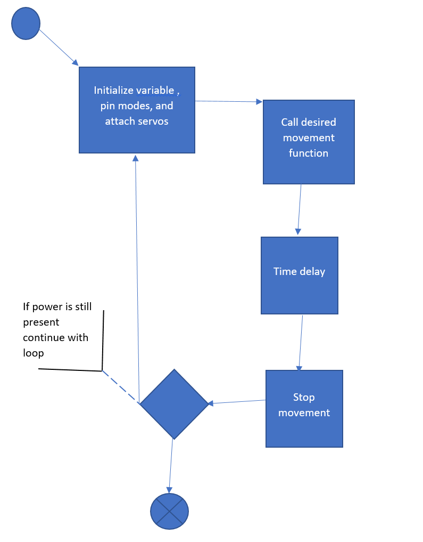Below the is our team’s design for testing script for the servos. Note that the functions to be called for directional control, just changes the writeMicroseconds values for each servo. To go forward the values, left to right servo, are 1700 and 1400. To reverse or go backwards the values are 1700 for the left and 1400 for the right. To move right the values are 1700 for both servos and left being 1300 for both.

## Line Following Design

***Place your flow diagram here for when you were completing your test plan***

# Testing

***Describe your testing process. Including the reference for your test plan and meeting minutes. Example below for the Servo test plan. (State any errors with your test, whether the tests passed or failed, and any changes to your software design if any were done.)***

## IR Sensor Testing Script

## TCS34725 RGB Color Sensor Testing Script

## Servo Testing

Append C holds our test plan for the servos, along with the results of our tests. There is a small error to note in the steps to conduct our test plan. This error is that we never state that the switch located on the boe-bot shield needs to be put at location 2, which gives power to the servos and breadboard. This was changed in the test plan to reflect the true testing steps. After conducting each test, it was concluded that the software design for moving the servos satisfies the requirement 5 and all sub-requirements of 5.

## Line Following

# Conclusion

***State lessons learned, results from your three tries at the ‘drag race’ line following, review of team dynamics, and any improvements that should be done to complete the stage if failure was meant during this project. (Failure: not completing the stage)***

# Appendix A: IR Sensor Testing Script

***Insert your test plan***

# Appendix B: TCS34725 RGB Color Sensor Test Plan

***Insert your test plan***

# Appendix C: Servo Test Plan

***Insert your test plan***

Servo Movement

Test Plan

Revision: 0.2

August 10, 2017

Embry-Riddle Aeronautical University

600 South Clyde Morris Boulevard

Daytona Beach, FL 32114

**Revision History**

|  |  |  |  |
| --- | --- | --- | --- |
| **Rev** | **Date** | **Author** | **Description** |
| 0.1 | Aug 9, 2017 | Ghelarducci | Initial build |
| 0.1 | Aug 10, 2017 | Ghelarducci | Edit the switch step for all tests |

# Introduction

The purpose of this document is to specify the methodology of testing the product against a set of related requirements. Refer to Appendix A for Requirements. The product to be tested are the servo motors on the boe-bot.

# Test Plan

|  |  |  |  |  |  |
| --- | --- | --- | --- | --- | --- |
| The following sequence satisfies:  **Req. 5.3 and 5.4** | | | | | |
| Step | Input/action | Expected Result | Date Ran | Pass/Fail | Comments |
| 1 | 1. Open the ServoMove.ino file 2. Uncomment the following lines : Forward();   delay(demoTime);  Within the loop() function   1. Connect the boe-bot via usb to your computer 2. Upload the code to the boe-bot 3. Once done, move the switch to position 2 | Should move forward for a given time of demoTime | Oct 4th 2017 | pass | The boe-bot does not go straight, but only for short periods of time |

|  |  |  |  |  |  |
| --- | --- | --- | --- | --- | --- |
| The following sequence satisfies:  **Req. 5.4 and 5.5** | | | | | |
| Step | Input/action | Expected Result | Date Ran | Pass/Fail | Comments |
| 1 | 1. Open the ServoMove.ino file 2. comment the following lines : Forward();   delay(demoTime);  Within the loop() function   1. Uncomment the following lines : Backward();   delay(demoTime);  Within the loop() function   1. Connect the boe-bot via usb to your computer 2. Upload the code to the boe-bot 3. Once done, move the switch to position 2 | Should move backwards for a given time of demoTime and then stop for a given time | Oct 4th 2017 | pass | The boe-bot does not go straight, but only for short periods of time |

|  |  |  |  |  |  |
| --- | --- | --- | --- | --- | --- |
| The following sequence satisfies:  **Req. 5.2 and 5.5** | | | | | |
| Step | Input/action | Expected Result | Date Ran | Pass/Fail | Comments |
| 1 | 1. Open the ServoMove.ino file 2. comment the following lines : Backward();   delay(demoTime);  Within the loop() function   1. Uncomment the following lines : turnRight();   delay(demoTime);  Within the loop() function   1. Connect the boe-bot via usb to your computer 2. Upload the code to the boe-bot 3. Once done, move the switch to position 2 | Should move turnRight for a given time of demoTime and then stop for a given time | Oct 4th 2017 | pass | None |

|  |  |  |  |  |  |
| --- | --- | --- | --- | --- | --- |
| The following sequence satisfies:  **Req. 5.1 and 5.5** | | | | | |
| Step | Input/action | Expected Result | Date Ran | Pass/Fail | Comments |
| 1 | 1. Open the ServoMove.ino file 2. comment the following lines : turnRight();   delay(demoTime);  Within the loop() function   1. Uncomment the following lines : turnLeft();   delay(demoTime);  Within the loop() function   1. Connect the boe-bot via usb to your computer 2. Upload the code to the boe-bot 3. Once done, move the switch to position 2 | Should turn left for a given time of demoTime and then stop for a given time | Oct 4th 2017 | pass | None |

# Appendix C-A

## Requirements:

The following requirements were taken from Stage 1’s project description.

**Functional:**

1. Teams shall demonstrate the ability to move a servo driven wheel.
   1. Teams shall demonstrate turning the robot left.
   2. Teams shall demonstrate turning the robot right.
   3. Teams shall demonstrate moving the robot forwards.
   4. Teams shall demonstrate moving the robot backwards.
   5. Teams shall demonstrate the action of stopping the robot.

**Non-Functional:**

None.

# Appendix D: Line Following Test Plan

# Appendix E : Meeting Times

|  |  |  |  |
| --- | --- | --- | --- |
| 9/30/17 | David, Manny | Began bot building process | 2 hours, 2 hours |
| 10/3/17 | Manny | Soldered the RGB sensor | 1 hour |
| 10/6/17 | David, Manny, (Brock) | Started programming and testing | 2 hours, 1.5hours, 30min |
|  |  |  |  |
|  |  |  |  |
|  |  |  |  |
|  |  |  |  |
|  |  |  |  |